

TrueERP Additions Contract
Additions Contract Guideline;
This document is used if you require an addition or a change to the software functionality. The 4 steps outlined are; 1. Specifying Requirements, 2. Programming Cycle, 3. Alpha Testing. 4.Completion and Beta version. These steps will explain the various processes and potential time frame involved.

We at TrueERP offer free and paid additions;
- Free additions are offered if the intended addition is to benefit all of our end users of the software.
- Paid additions will see you fast tracked and moved to the front of queue naturally.
All Additions will be placed into the queue of works in ERP Version History, this is updated each Friday. Please discuss this process with your Project Manager.
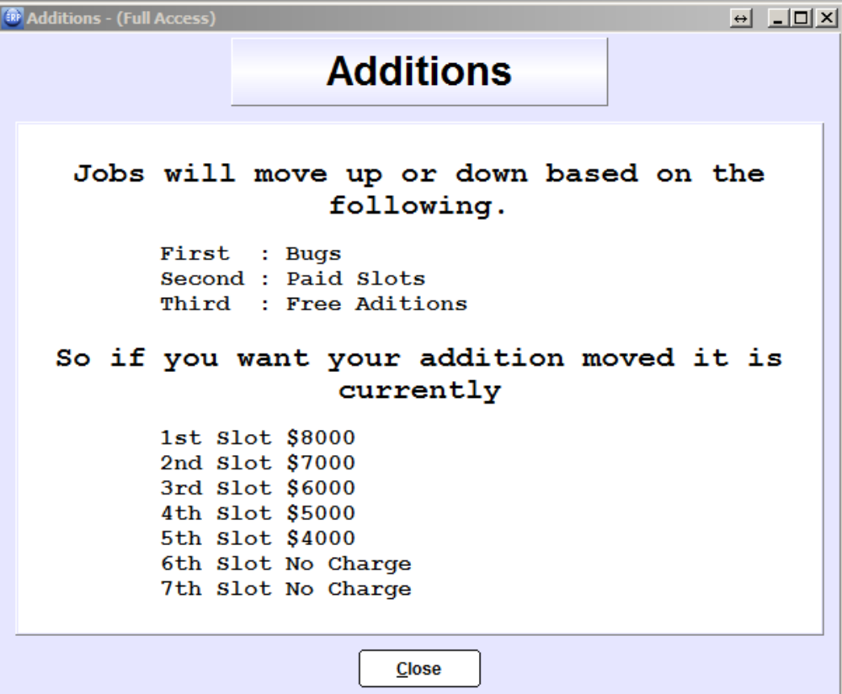

It is important that Additions are referenced inline with the TrueERP screen of the relevant module. This will allow programmers to easily relate to the module and potential change / requirement. Each screen shot, should not need more than 4 lines of text to explain the intended addition / change. If it does, we will need another screen shot taken to reference against this.

If you are requiring additions and you are a new Customer of TrueERP. You will need a prioritised list, to reference at what stage you will go live with the additions. Therefore what are must have addition critical to go live, which is separate to a, would be nice to have addition. Please see your Project Manager to arrange screen shots

The following page will show you the general flow of the request for Software Additions and the processes involved.
Software Additions Process

Specifications
Specifying Requirements
Generating a Quote
- Dollars
- Time
- Accept Criteria

Clarification
Stage 1 Version

Quote

Quote Acceptance

_________________________________________________________________________

Quote booked in Show Me

Programming
- Average 3 Cycles
Clarification
Stage 2

Programming

Testing

_________________________________________________________________________

Alpha Version Testing

Testing
- Average 4 Cycles

Clarification
Stage 3

Programming

Testing

_________________________________________________________________________

Completion
Alpha Version Testing
Stage 4
Alpha Acceptance

Beta Final Version

TrueERP Additions Contract

Company Name:____________________________________________

This TrueERP Additions Contract (“Additions Contract”) does not supersede the Licence Agreement and its terms and conditions, executed by the Licensor. By executing this agreement, the Licensee acknowledges and accepts:

- That it is bound to the samsimoe terms and conditions set out in the Licence Agreement;
- That any payment due to the Licensor pursuant to the Licence Agreement cannot be withheld pending the completion, rectification, errors or amendments of the software resulting from this or any further additions the Licensee may require;
- The Licensee will use all its endeavours to ensure that any additions are implemented as quickly as possible. However, the Licensor cannot provide a timeframe, warranty or indemnity with respect to the implementation of any amendments requested by the Licensee. The completion/go live date contained in the License Agreement will be varied as a result of the execution of this agreement;
- The Licensee does not warrant that the software will function in the same nature with the same functionality displayed prior to any additions being implanted;
- Should additions be required in addition to those sought pursuant to this agreement, the Licensee will be asked to sign off on screenshots provided by the Licensor. A further Additions Contract will not be executed;
- The go live date provided by the Licensee following the execution of this agreement will not be varied or extended further, in the event that further additions are required; and
- The Licensee will be asked to list its additions by way of priority for completion. The Licensee will provide the Licensor with a go live date which will be effective at the completion of one of those additions..

Stage 1

Specifying Requirements
The document should always start with the goal.

For Example: What we are trying to achieve is the ability to make individual products come into individual departments from when raising a Purchase Order. Stock to each department will be automatically adjusted to suit.

The images that you need should be screen shots from within TrueERP or by making simple drawings from MS Office programs. Top of every page must include; Date, ERP Version, Company Name

There should be no more than 4 lines of text per image. See below example. Your Project Manager will be assisting you to create the screen shots
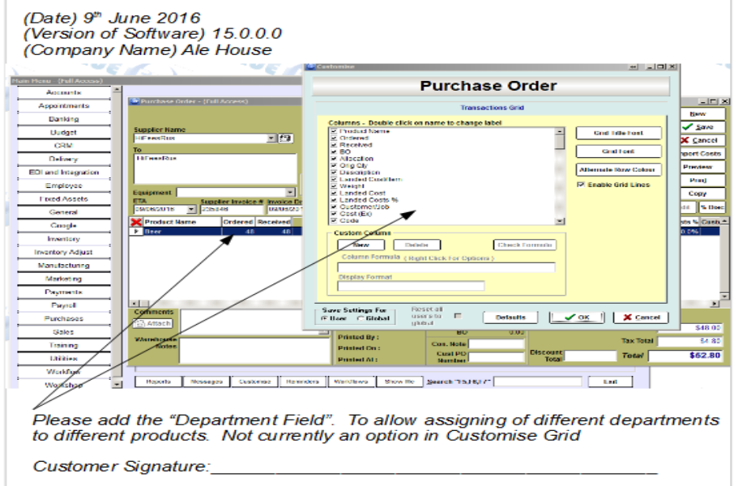

The finished screen shots must be confirmed with your Project Manager (PM). In most cases we recommend that your PM actually does the specifying with you to ensure that clarity for our programmers is achieved and TrueERP doesn't already have a similar solution.

If you’re a new customer, your Additions request must reference “Will go live at this point with addition/s”. Eg “You might specify 3 Additions, but after the first addition, we will go live once we have the first addition working”. If it doesn't TrueERP will send it back to the Customer and PM, to ensure this is clearly labelled and marked on the additions screen shots

Every page of images and text must be signed and returned to TrueERP for quoting and
confirmation. Typically this is done via email.

Quote accepted

- Clarification may be required on the images supplied
- TrueERP will determine if works is free or to be quoted
- A quote with the specifications will be sent from TrueERP back to Customer
- Once the signed quote and specs are returned to TrueERP and paid for. Additions is booked into the Show Me, ERP Version History List in your TrueERP database

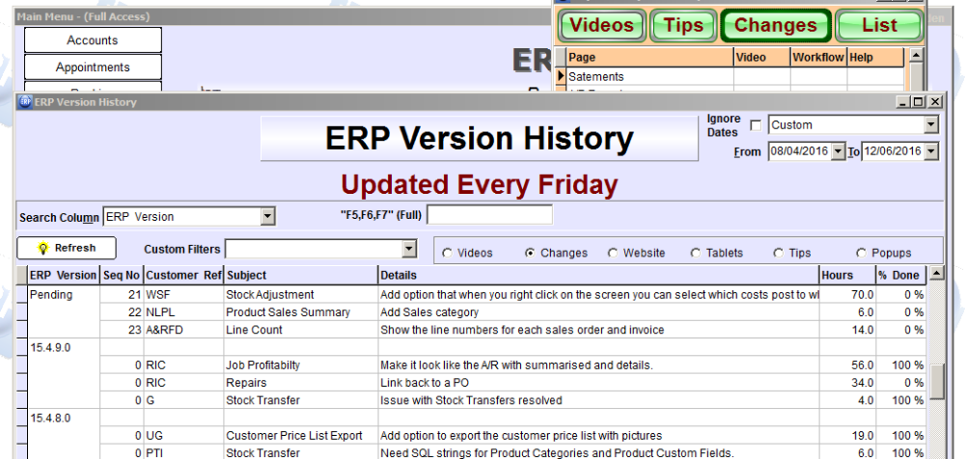

_________________________________________________________________________

Stage 2

Programming Cycle

The accepted quote will be booked into the programming cycle ready for commencement.
Time for when the programming is commenced will depend largely on the amount of work
booked before the accepted quote, but in simple terms the order of work.

1. Bugs and Issues
2. Specification adjustments
3. Paid Additions
4. Free Additions

Once programming commences, there may be a number of calls back to you to clarify any unknowns with specifications. On completion by the programming team, the work is passed to the basic testing department. Initial testing is done by this area to identify obvious flaws. Any obvious flaws are handed back to the programmers for reprogramming---The process repeats. This cycle is repeated an average of 3 times.

_________________________________________________________________________

Stage 3

Alpha Testing

Basic testing is performed by TrueERP programmers. Alpha Testing is done at the company office.

Alpha Test Versions Are Not to be used on any live files or active databases. Alpha
Versions get released onto a Test Server environment only.

The Alpha version is what has been interpreted by the programmers, so the accuracy of the Specifying Requirements is critical. As this will determine how through the programmers have made the relevant changes in line with your expectations

You must at this stage confirm that what you have specified has been completed. Any changes you require to the Alpha Version will be put back into the programming cycle, any additions must be again be quoted and added on the programming cycle. This cycle is repeated an average of 4 times.

_________________________________________________________________________

Stage 4

Completion

If all additions (customisation) are completed as required and been fully tested on your Test Server, the Alpha version is then added to the finished full version of TrueERP. This is updated and reflected in Show Me, Changes, ERP version History List. This shows you the version and the changes made in that particular release of an Alpha version. At no stage will we approve for a Live Database to go onto an Alpha version release of the software.

Live Database's may be updated from time to time, once we make a Beta version. It is at this stage, we can move you off the current production version and allow your live data base to upgrade to the current Beta version. This will allow your company to have access to the changes in your Live Database.

Customer Name: ________________________________________________
Company Name: ________________________________________________
Customer Signed: ________________________________________________
Date: ________________________

